PF Lab assIgnment#3

Mohammad Yehya, BCS-213G, 21K-3309

#include <stdio.h>

int main(){

# //Q1

printf("The datatype is string");

printf("\nThe datatype is integer");

printf("\nThe datatype is integer");

printf("\nThe datatype is double");

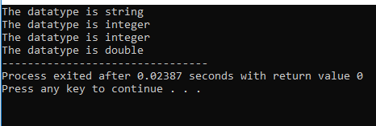

# //Q2

int Num1,Num2,temp;

printf("Enter two numbers \nNum1 = ");

scanf("%d",&Num1);

printf("\nNum2 = ");

scanf("%d",&Num2);

printf("The value of Num1 was :%d and the value of Num2 was :%d\n", Num1,Num2);

temp = Num1;

Num1 = Num2;

Num2 = temp;

printf("The new value of Num1 is :%d and the value of Num2 is :%d", Num1,Num2);

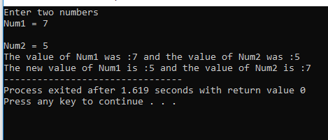

# //Q3

float Ang1,Ang2;

printf("Input two angles of a triangle\nAngle1 :");

scanf("%f",&Ang1);

printf("\nAngle2 :");

scanf("%f",&Ang2);

printf("The last angle of the triangle is :%f", 180 - Ang1 - Ang2);

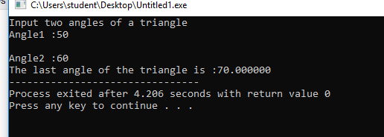

# //Q4

float salary;

printf("Please enter your salary.\nSalary :");

scanf("%f",&salary);

printf("After deducting taxes and daily allowances your salary is :%f ", salary*(0.95)*(0.98));

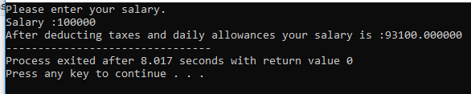

# 

# //Q5

float SpicBurg = 20;

float Fries = 10;

float Lemonade = 15;

float IceCream = 25;

float tax = 2.5;

float discount = 5;

printf("The price before the discount is :%f",(SpicBurg + Fries + Lemonade + IceCream)*(100+tax)/100);

printf("\nThe price after the discount is :%f",((SpicBurg + Fries + Lemonade + IceCream)*(100+tax)/100)*(100- discount)/100);

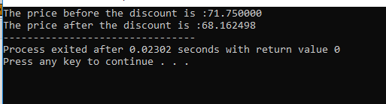

# 

# //Q6

int noadults;

int nokids, totalprice;

printf("Please enter number of adults :");

scanf("%d",&noadults);

printf("\nPlease enter number of kids :");

scanf("%d",&nokids);

totalprice = 100*noadults + 500*nokids;

printf("The total price is :%d",totalprice);

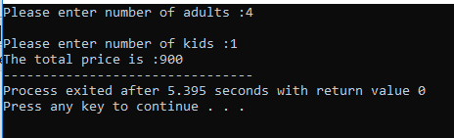

# 

# //Q7

float tempfar;

float tempcels;

printf("Enter temperature in Farhenheit :");

scanf("%f", &tempfar);

tempcels = (tempfar - 32) * 5 / 9;

printf("The temperature in celcius is :%f",tempcels);

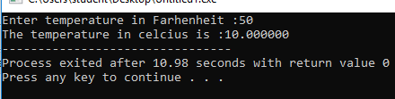

# //Q8

float width , length , area;

printf("Please enter width :");

scanf("%f",&width);

printf("Please enter length :");

scanf("%f",&length);

area = width * length;

printf("The area of the rectangle is :%f",area);

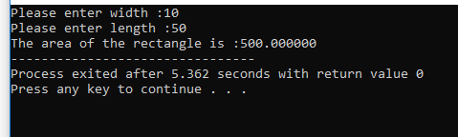

# 

# //Q9

float mon1,mon2,mon3,mon4,total,initialweight;

printf("Enter initial weight :");

scanf("%f",&initialweight);

printf("Please enter the weight lost in the first month :");

scanf("%f",&mon1);

printf("\nPlease enter the weight lost in the second month :");

scanf("%f",&mon2);

printf("\nPlease enter the weight lost in the third month :");

scanf("%f",&mon3);

printf("\nPlease enter the weight lost in the fourth month :");

scanf("%f",&mon4);

total = mon1 + mon2 + mon3 + mon4;

printf("Average weight lost is :%f",(total/4));

printf("\nYour weight right now is :%f", initialweight - mon1 - mon2 - mon3 - mon4);

}

